**In class Programming Assignment – 6**

Avanthi Madhuri

700764030

**GitHub Link:** <https://github.com/Avanthireddy04/NeuralNetwork_assignments/tree/main/ICP_6>

**Problem 1:** Basics of LSTM, Types of RNN, Sentiment Analysis on the Twitter data set

**Solution:**

1. Saving the model and using the saved model to predict on new text data.

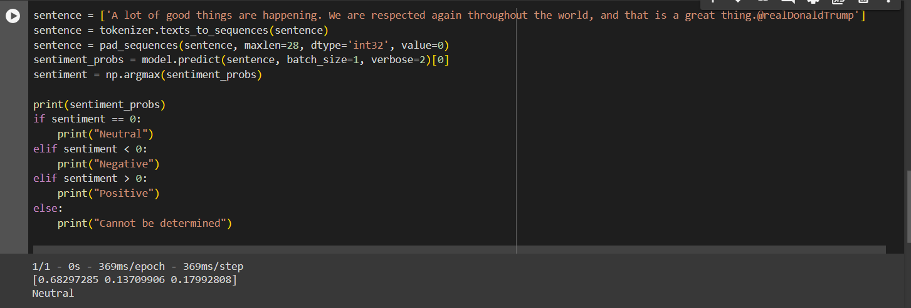

1. Applying GridSearchCV on the source code provided in the class.



